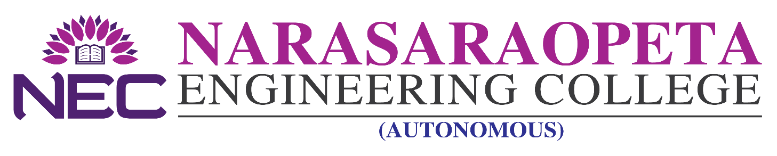

NEC(A)/CE/CIR/2023/04/14 EXAM CELL (AUTONOMOUS)
Date: 25-04-2023
CIRCULAR

The following are the dates for collection of fees for Revaluation.

S.No. | YEAR / SEM | AMOUNT | Last Date for Payment:  01.05.2023
1 | (R20) I B.TECH I SEM  REGULAR & SUPPLE EXAMINATIONS  FEB - 2023 | 1000/-
2 | (R19) M.TECH I SEM  REGULAR & SUPPLE EXAMINATIONS  MARCH- 2023 | 1200/-
3 | (R19) MBA I & III SEM  REGULAR & SUPPLE EXAMINATIONS  FEB / MARCH - 2023
4 | (R20) MCA I & III SEM  REGULAR & SUPPLE EXAMINATIONS  FEB- 2023

Note to the Candidate: Procedure to pay the Revaluation Fee:-

Student needs to visit the examination section and pay the examination fee using POS Machine which is available with the examination section. Students can use Debit card/Credit card/UPI payments. After the payment, a receipt will be issued to the student. Students need to attach the receipt to the application form & submit the same to the examination section. Without submitting the application, student will not be treated as registered for the supple examinations. Supple application can be obtained from exam section or from college website: www.nrtec.in >>
Exam Cell >> Autonomous >> Downloads.
Please note that payments after 01.05.2023 will not be accepted and
no refund will be given.

Mere payment of examination fee does not guarantee eligibility for appearing for examination, it is subject to fulfilment of academic requirements and other requirements specified time to time by the college authorities.

Date: 25.04.2023 Chief Controller of Examinations.

. 