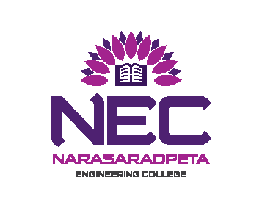
NARASARAOPETA ENGINEERING COLLEGE (AUTONOMOUS) : NARASARAOPET
EXAMINATION SECTION

I B.TECH END EXAMINATIONS

NOTIFICATION

Notification No. NEC(A)/CE/I B.TECH/II SEM/SUPPLEMENTARY/2017/10/13

I B.TECH II SEMESTER SUPPLEMENTARY EXAMINATIONS
R16 REGULATIONS
DECEMBER - 2017

CANDIDATES APPEARING FOR THE ABOVE EXAMINATIONS COMMENCING
FROM 05-12-2017 ARE INFORMED THAT THE APPLICATIONS WILL BE RECEIVED AS PER THE TIME SCHEDULE GIVEN BELOW:

EXAM REGISTRATIONS | LAST DATE
Without Late Fee | 31-10-2017
With Late Fee of Rs.100/- | 07-11-2017
With Late Fee of Rs.1000/- | 15-11-2017

FOR SUPPLEMENTARY EXAMINATIONS, EACH SUBJECT (THEORY / PRACTICAL) – 300/-

*Applications are also admissible up-to one day before the examination
with a fine of Rs.5000/-
Detailed Time Table for theory Examinations will be notified in the Departmental Notice Boards.

Note to the Candidate: Applications can be obtained at the college examination section and duly filled in applications should be handed over in the college examination section with necessary fee.

Mere payment of examination fee does not guarantee eligibility for appearing for examination, it is subject to fulfilment of academic requirements and other requirements specified time to time by the college authorities.

1. Laboratory / Project Examinations should be conducted from 27-11-2017 to 02-12-2017.

2. Laboratory / Project Viva Voce Examinations award lists are to be submitted to the Examination Section (Autonomous) on or before 05-12-2017.

Date: 24-10-2017 Chief Controller of Examinations.

